

**March 5, 2014 / People display format and photos revised by JPN staff 3/6/2014**

[**HERITAGE EXPO DRAWS HUNDREDS**](http://www.thetruecitizen.com/news/2014-03-05/People/HERITAGE_EXPO_DRAWS_HUNDREDS.html)

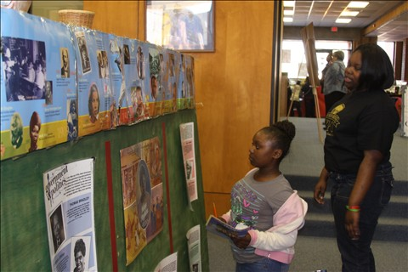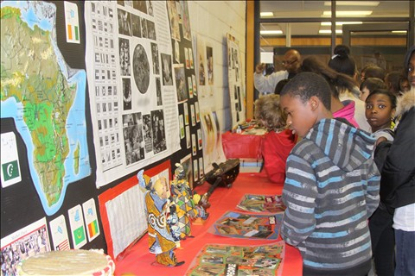Nearly 800 students took part in the Black Youth Heritage Expo at Boggs Rural Life Center in Keysville last week. The traveling hands-on exhibit highlights African American history with an emphasis on black cowboys and Buffalo Soldiers. According to organizers from the Joynt Production Network, local volunteers, including six Burke County High School juniors, acted as tour guides during the three days of field trips. The expo, which was entirely free to the public, also included a number of displays created by area students. Above right, SGA students look at a display featuring the former Boggs Academy’s sports teams. At right, SGA student Octavious Herrington studies a collection from Africa.

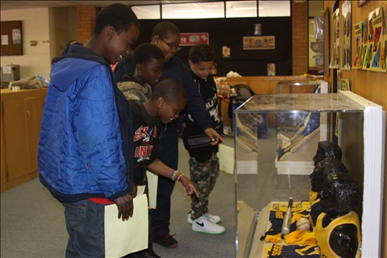

**[Expo Organizers want to say Thank You](http://www.thetruecitizen.com/news/2014-03-05/Editorial/Expo_organizers_say_thank_you.html)**

**Letter to the Editor**

**Editor:**

The Express H.O.M.E. Program would like to thank everyone that made the 2014 Black Youth Heritage Expo a success. Thanks to the support and the use of the Boggs Rural Life Center we feel we finally have the opportunity for growth in Georgia. 2014 marks our 20th year, now with 37 expositions under our belts we are grateful for a great celebration. But we feel we have to give a special thanks to Boggs Rural Life Center, Boggs Academy Alumni, Georgia Clients Council, C.A.$.H. Prosperity Campaign, M.A.B. SILK Productions, Joynt Production Network, The JPN Leadership Program, Burke County School District-Board Member & Boggs Alumni Dr. Ruby Saxon-Myles, Superintendent Dr. Rudy Falana, Principal of S.G.A.- Dr. Chequita Brady, Blakeney Elementary School-Assistant Principal- Jacqueline Jones, Burke County High School-Assistant Principal Anthony Chiles, Greater Georgia Printers, Enterprise Car Rental Branch #0374, The Epps Bridge UPS Store, The Cat Cares Team, Volunteers: Teens from the Community- Anthony, Austin, Brantley, Kelly and Ryan, JPN Youth Members- Tour Guides from Burke County High School and future leadership participants: Keldriauna Bonner, Shanterial Heath, Denesha Jenkins, Shanarvie Mickens, Kenisha Stapleton, and Samone Turner, Adult Volunteers Suyrene Beckett, Curtis Bell, Jacqueline Francois, Anthony Lonon and Robert Patterson. And I truly apologize if I missed anyone.

**“Expo Staff”  
Michael & Jacqueline Bosby  
2nd Generation - Ashley, & Ebonique Bosby,  
3rd Generation - Treyvon Baker, Chyna Hill, Jahnaye  
and Janyiia Harris,**